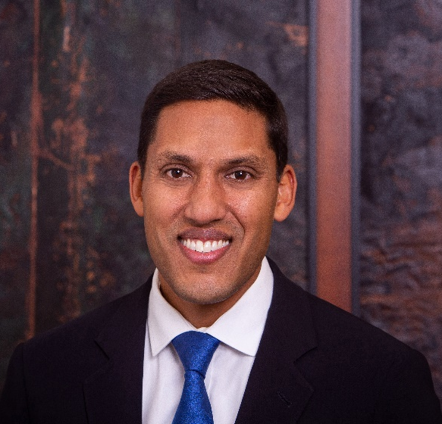
Dr. Rajiv J. Shah

President

The Rockefeller Foundation

Raj Shah is president of the Rockefeller Foundation, a global institution committed to promoting the well-being of humanity around the world through data, science and innovation. Under his leadership, the foundation raised and deployed more than $1 billion to respond to the COVID pandemic at home and abroad, launched a Pandemic Prevention Initiative to prevent future health crises, and created a $10 billion Global Energy Alliance for People and Planet to help secure a just and green recovery. Raj serves on President Biden’s Defense Policy Board and is a member of the American Academy of Arts and Sciences and the Council on Foreign Relations. He is married to Shivam Mallick Shah and they have three children.

